- Install git.
I already installed git in my local machine. So, I just updated the git version.
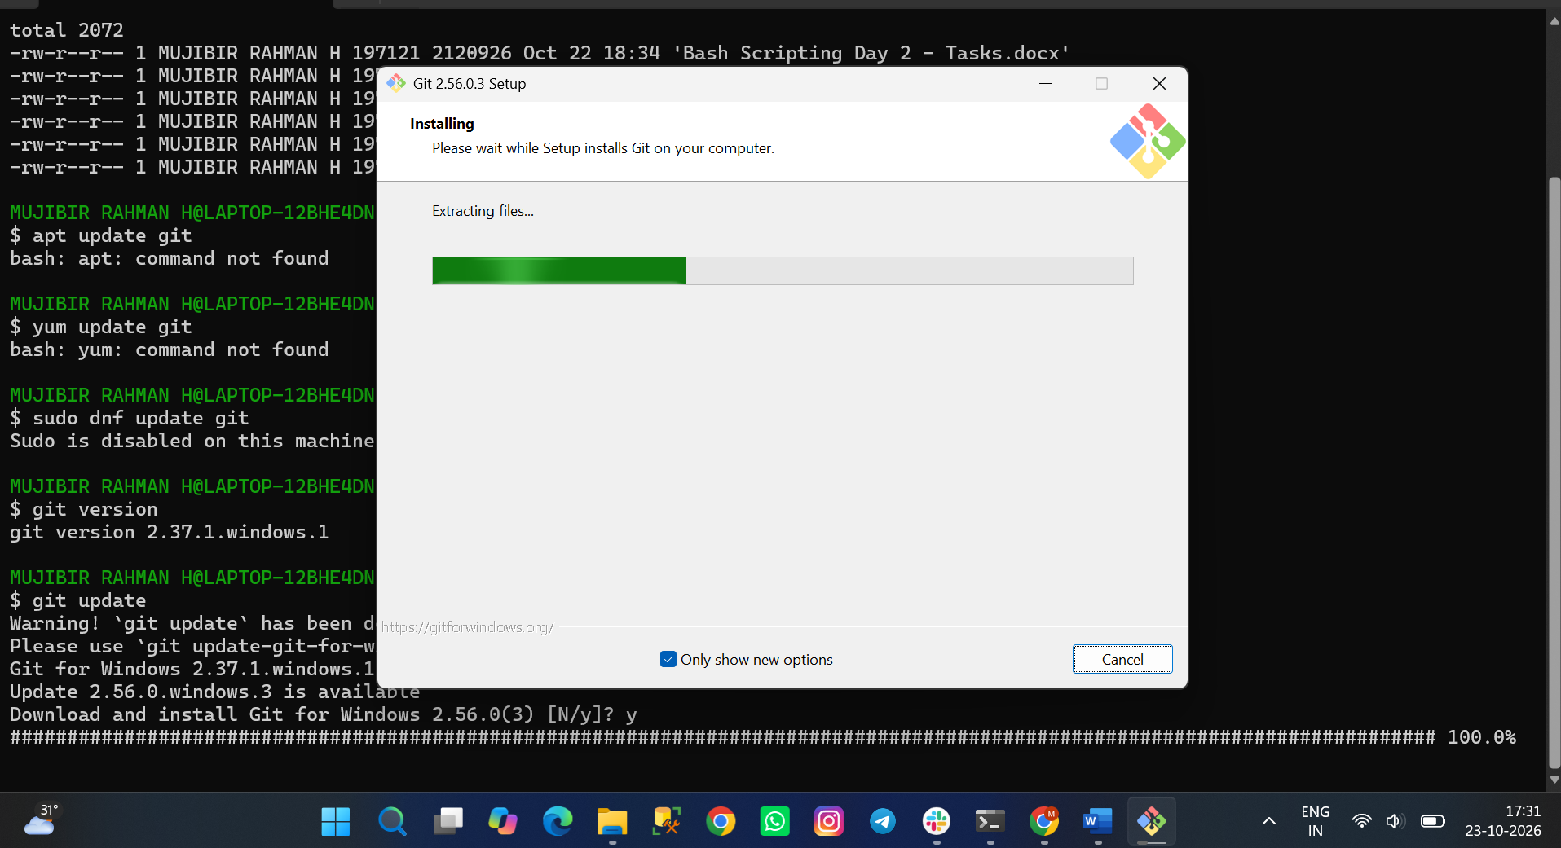
- Create a repo in github with README.md and .ignore file.
I just signup into github account, and right top corner we can able to see ‘+’ icon to create new repository.
There we need to fill the required details and will enable the readme & gitignore. Here I am selecting No.gitignore Because, We are just practicing the Linux and bash scripting only. It will vary depends on the project (Coding Language)
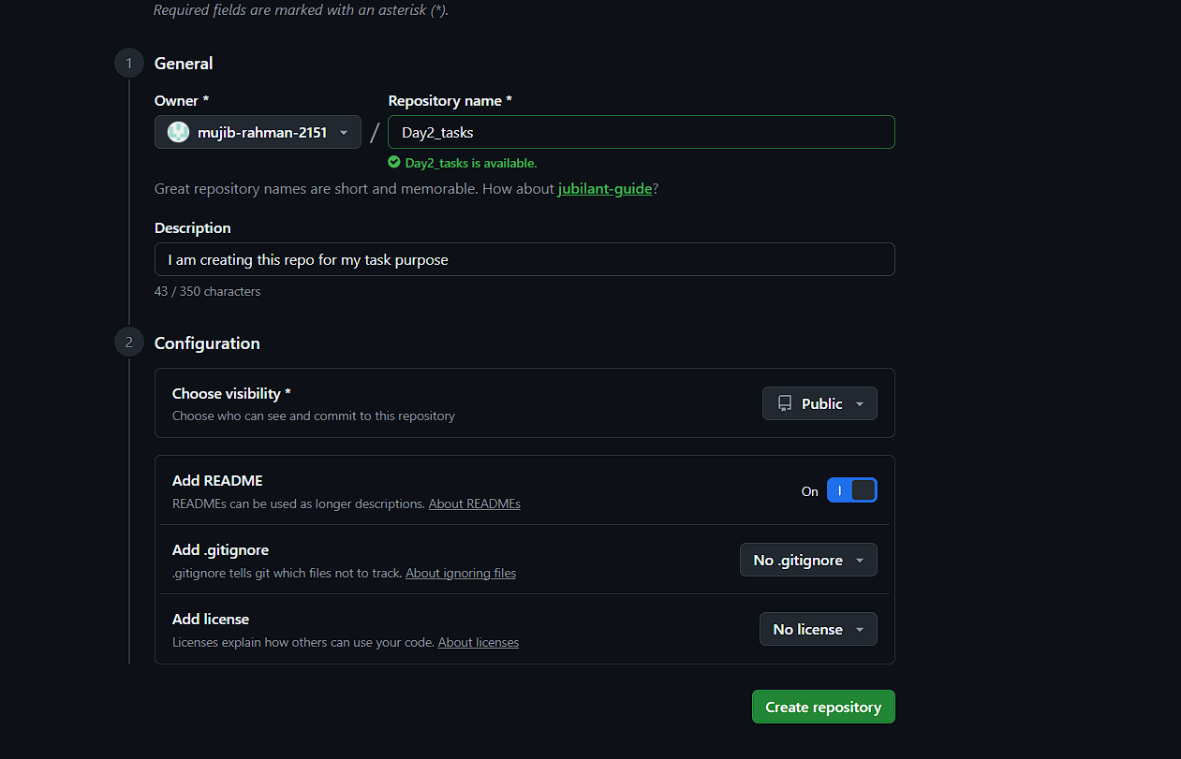
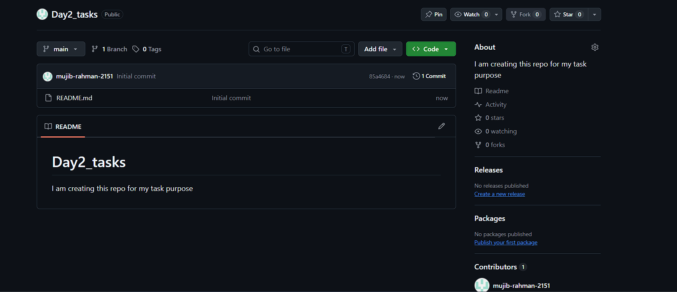
- Clone the created repo to local.
I just created one more file central repo and try to clone that into my local using below command
git clone <ssh_link>
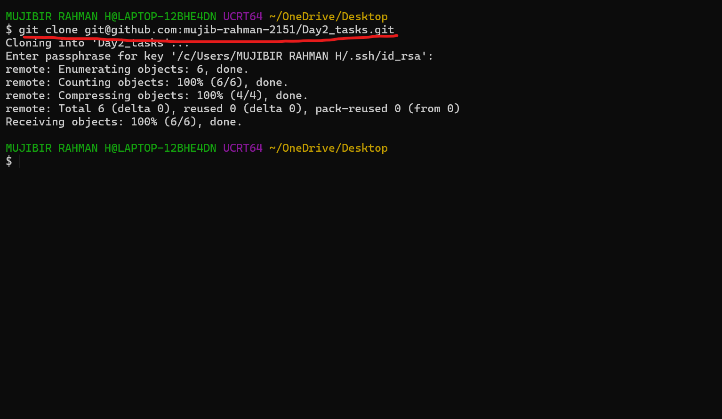
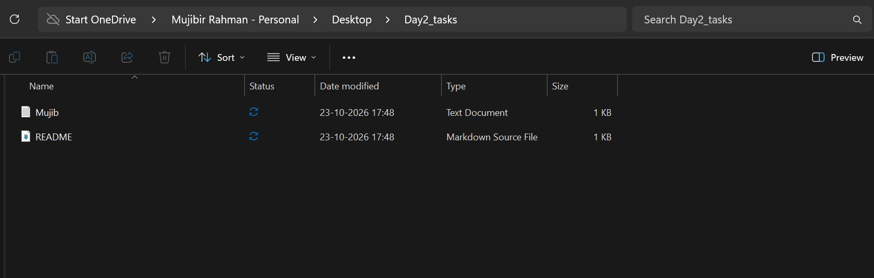
- Create two files in local repo.
I just created two files in local repo using touch command.
Here, rahman.txt & Mohan.txt two files created.
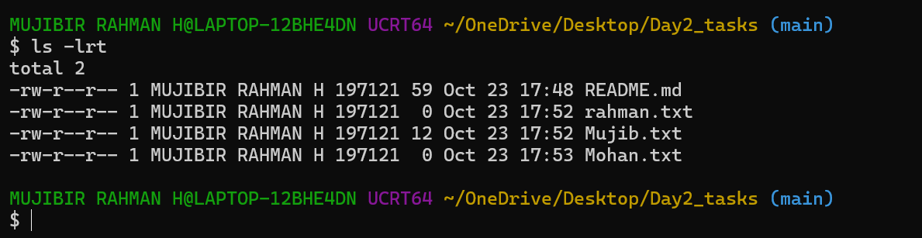
- Commit two files and push to central Repository.
I have created two files in local repo.
Just change the files untracking into tracking – using git add command
I commit the changes – using git commit
and then last step, I pushed the files from - local repo to central repo (git push command)
I just refreshed my github page – I am able to see the two files which I have pushed earlier from local.
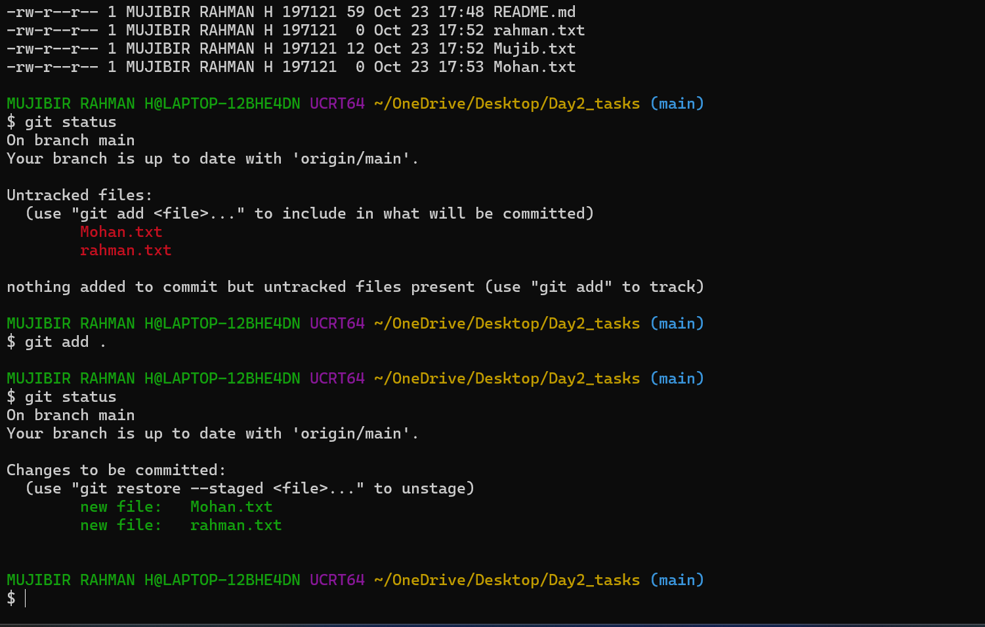
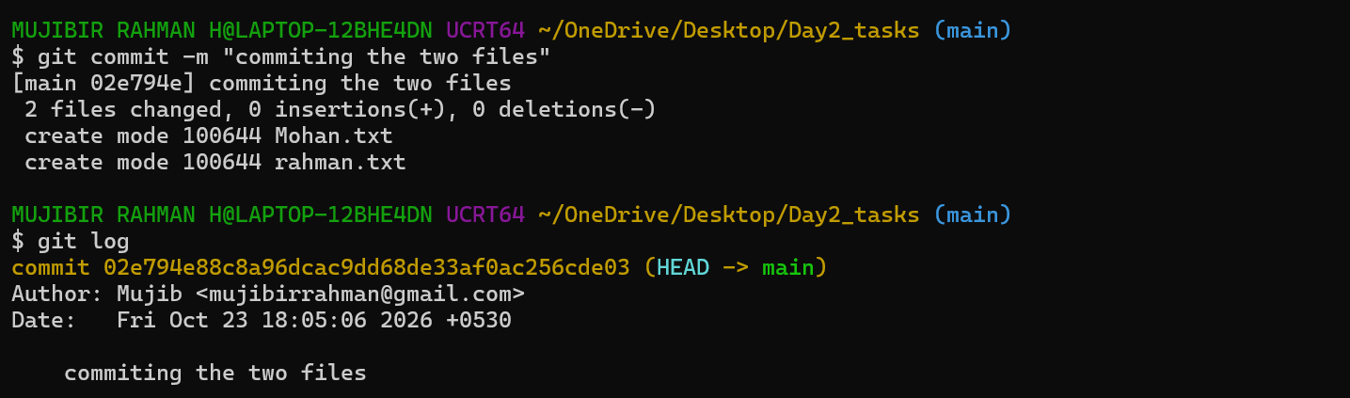
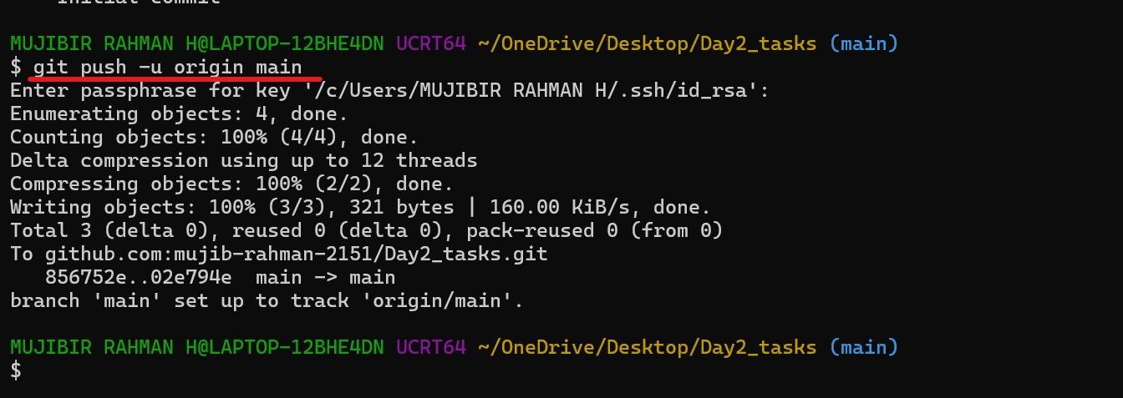
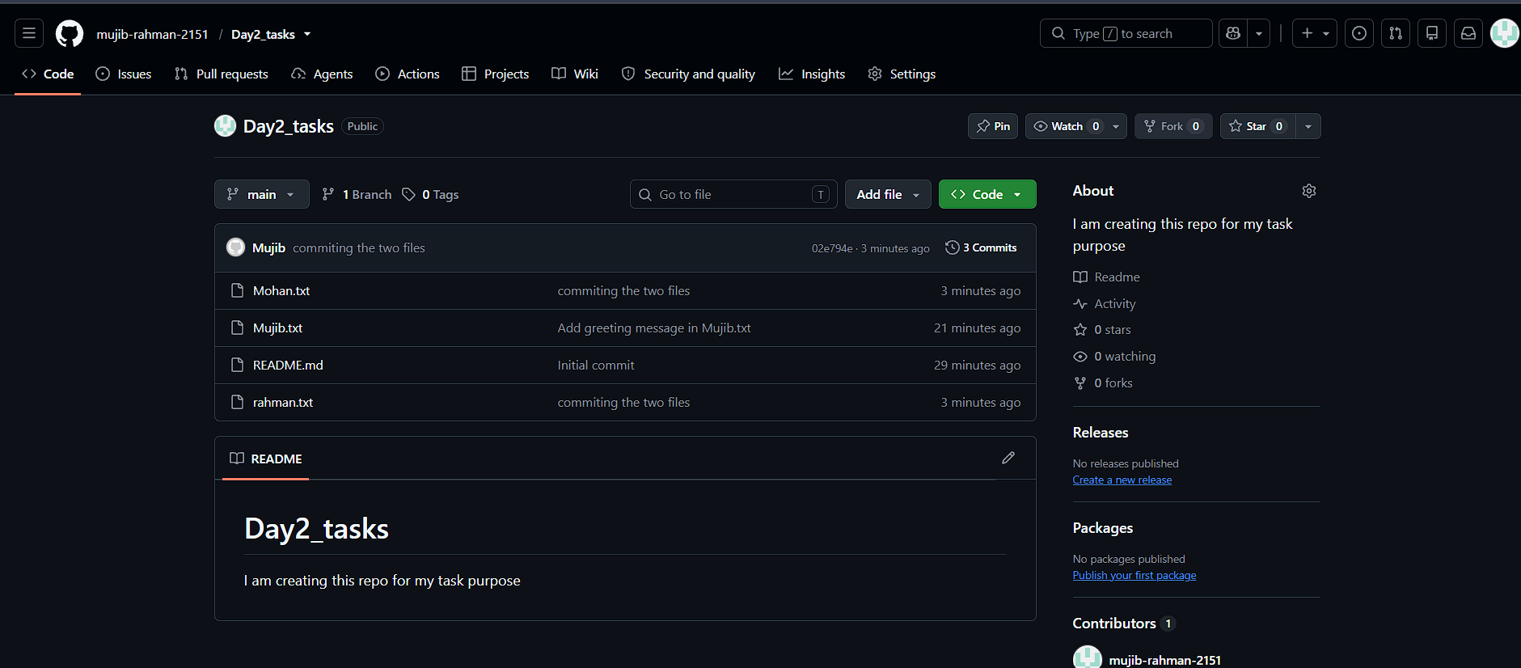
- Create a branch in local and create a sample file and push to central.
I just created one branch- called as master and sample file.
After commit the changes of the branch and sample files, I just pushed to central repo – with the help this below command.
git push – u origin master (We need to be in the new branch which we created)
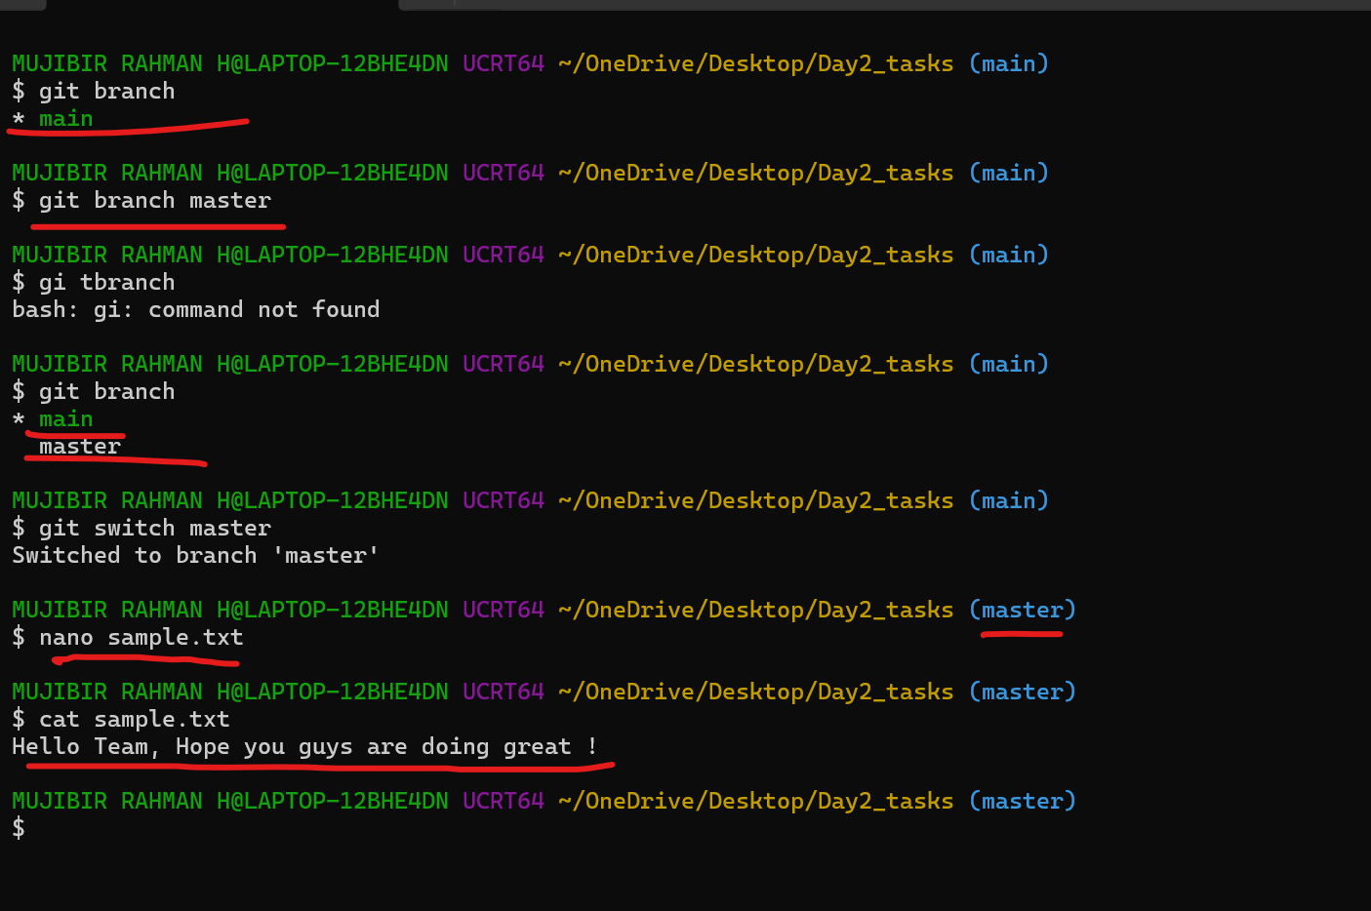
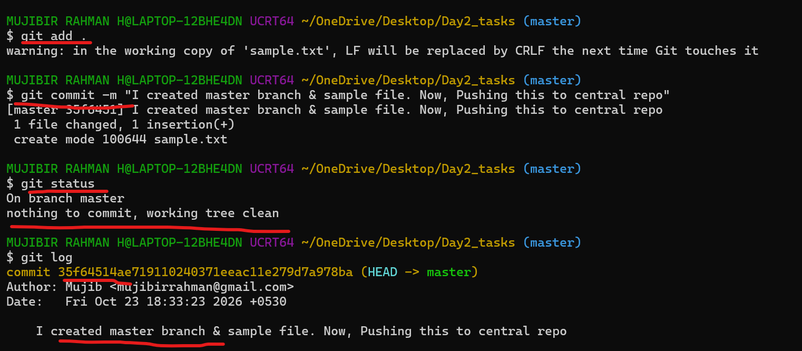
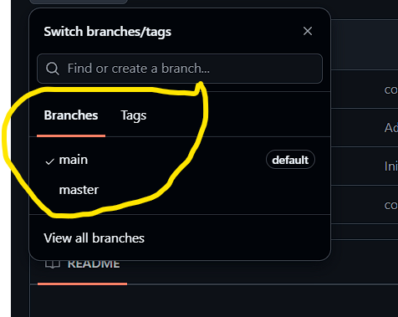
- Create a branch in github and clone that to local.
I created one branch in Github and tried to clone it on to local.
I faced a error while clone to local (file already exists)
So, I just moved to existing file path
tried to fetch – Using git fetch origin (origin is nothing but that is alias of repository)
git branch I am able to see the branch which I created in github.
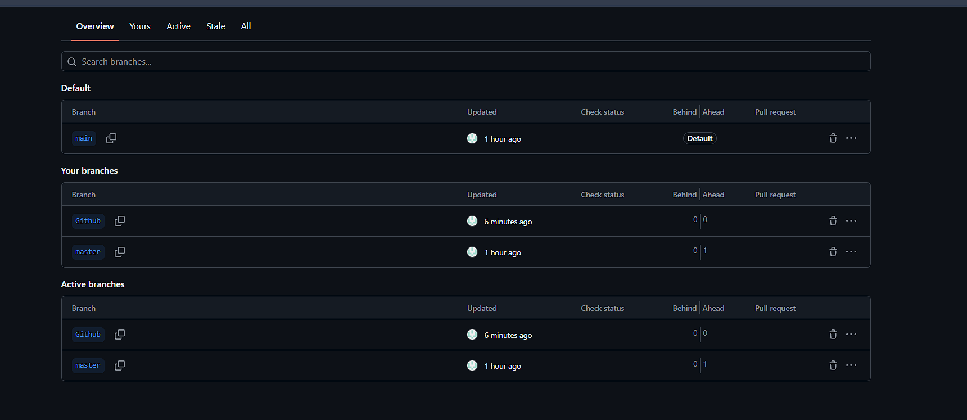
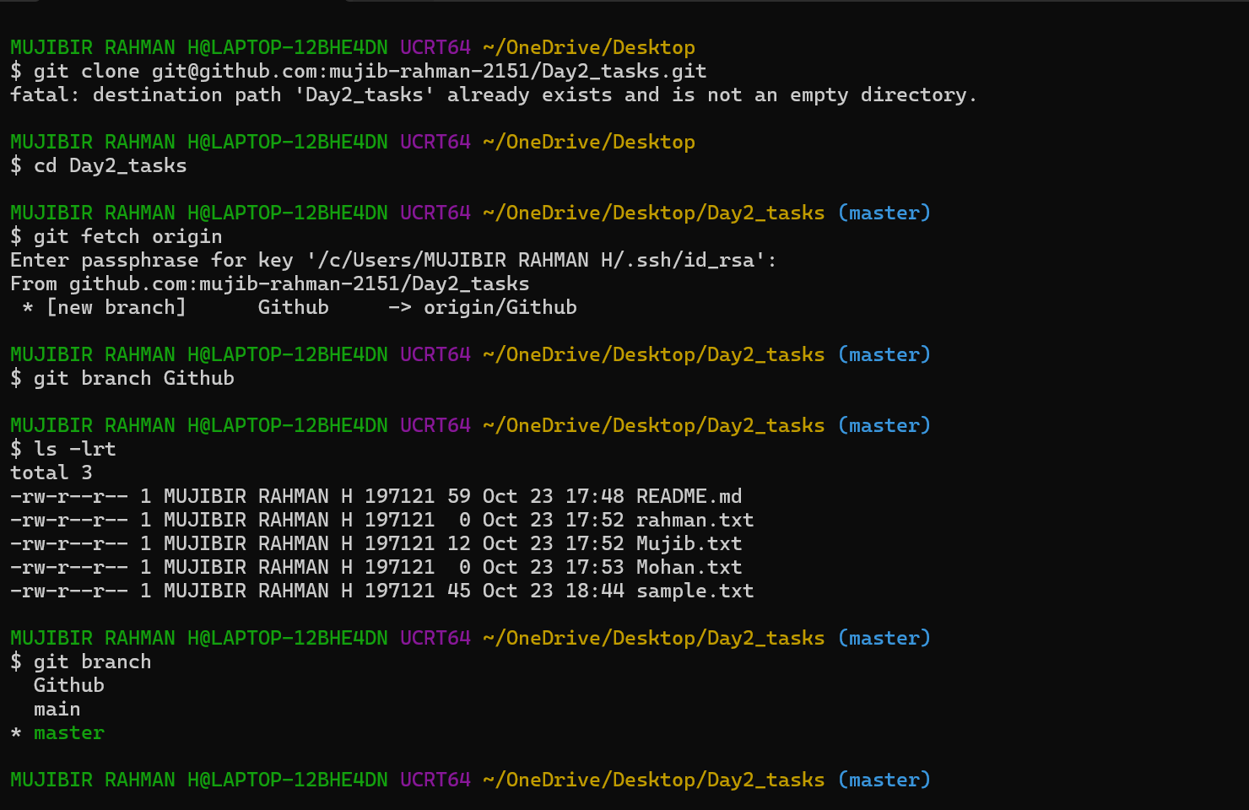
Second Method :
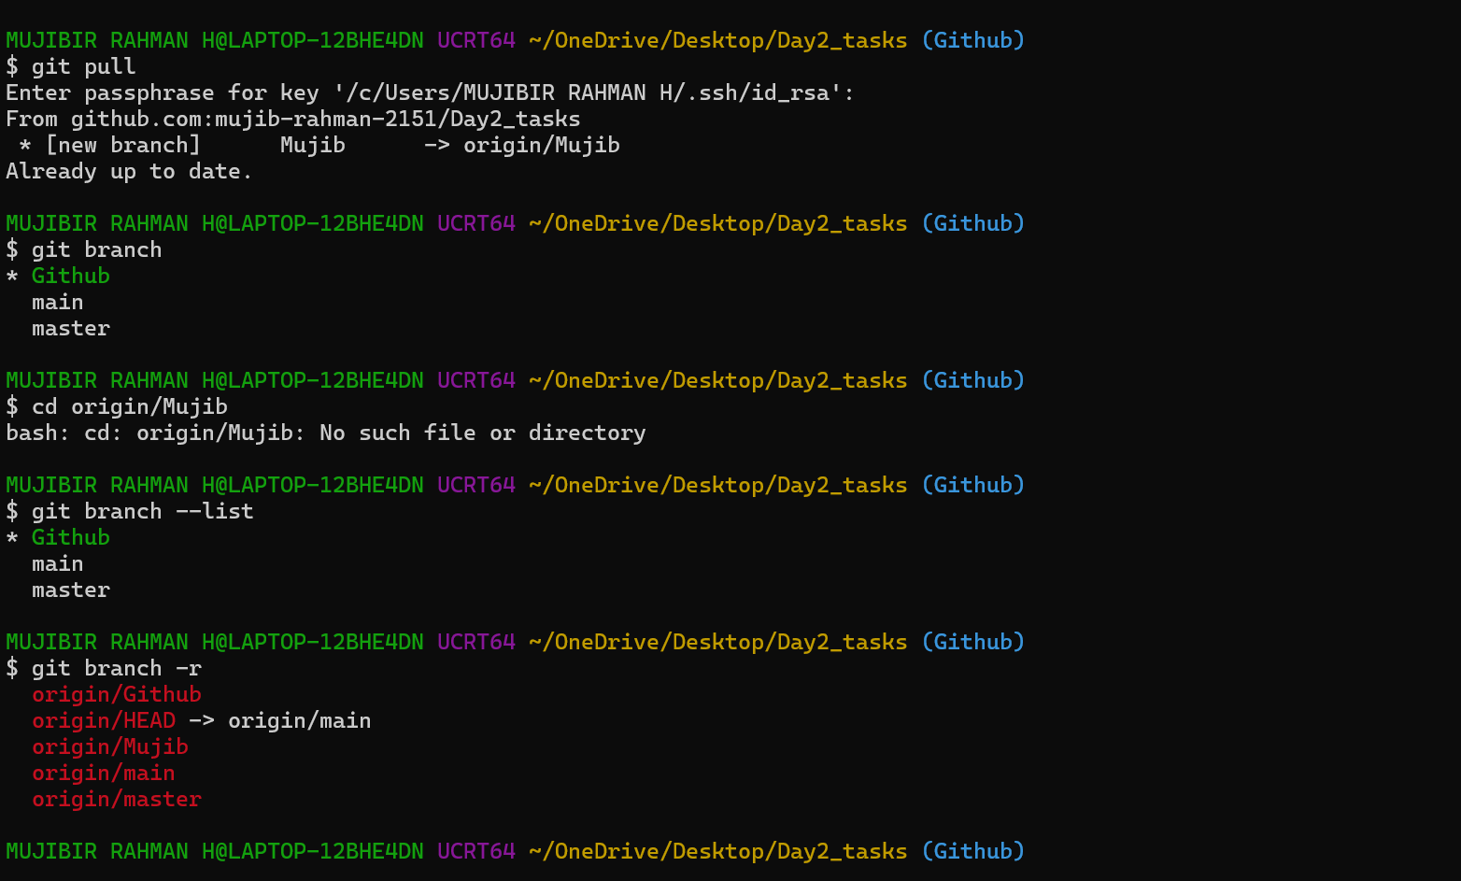
I just created one branch directly in central repo. I just need the changes reflect into local also.
Git pull command help us to get the updated changes in central repo.
So, I just pulled the changes and ensure that branch is in tracking process.
- Merge the created branch with master in git local.
I just created one branch based on previous ask.
Branch – Git hub. It already copies what are all the files available from base (Main).
So, I just created one new file in Git hub branch and changed into track & commit.
Now I merged the two branches using git merge <Branch name>
Now, it’s showing the new file.
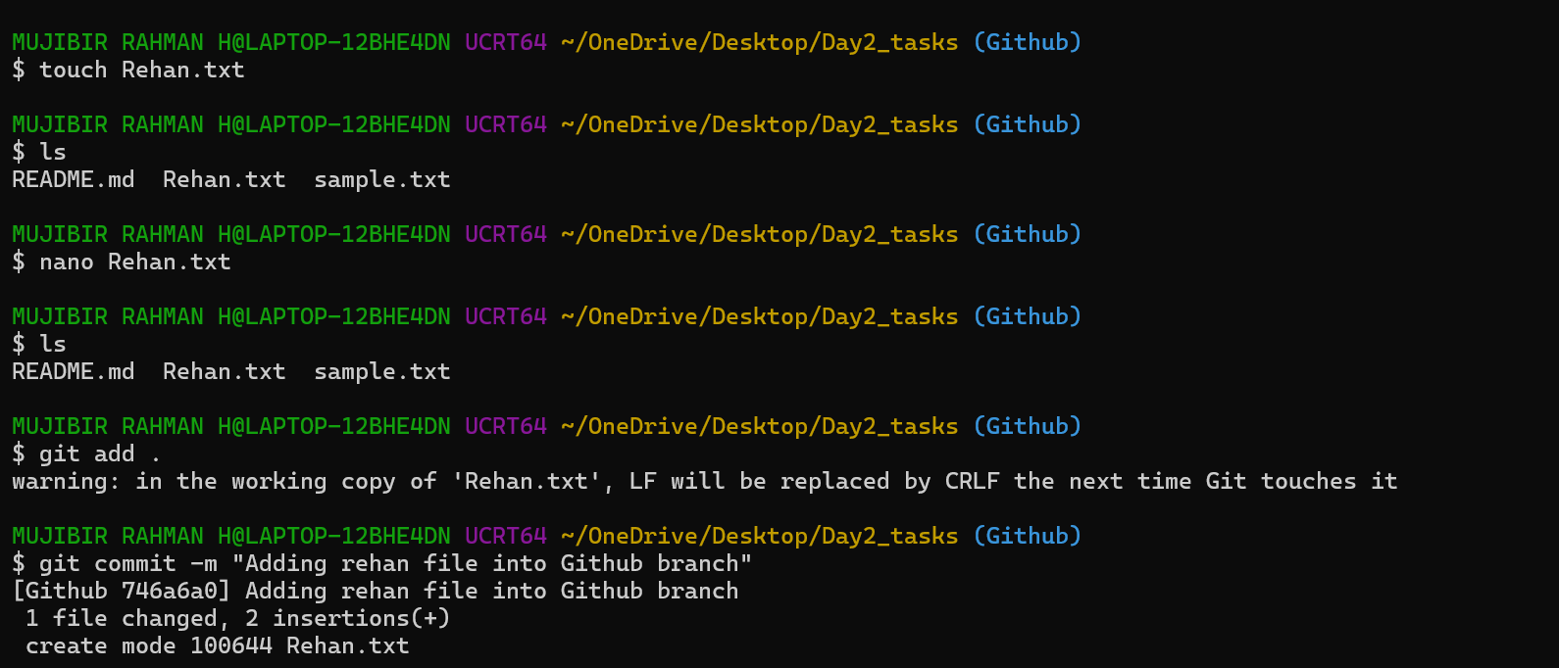
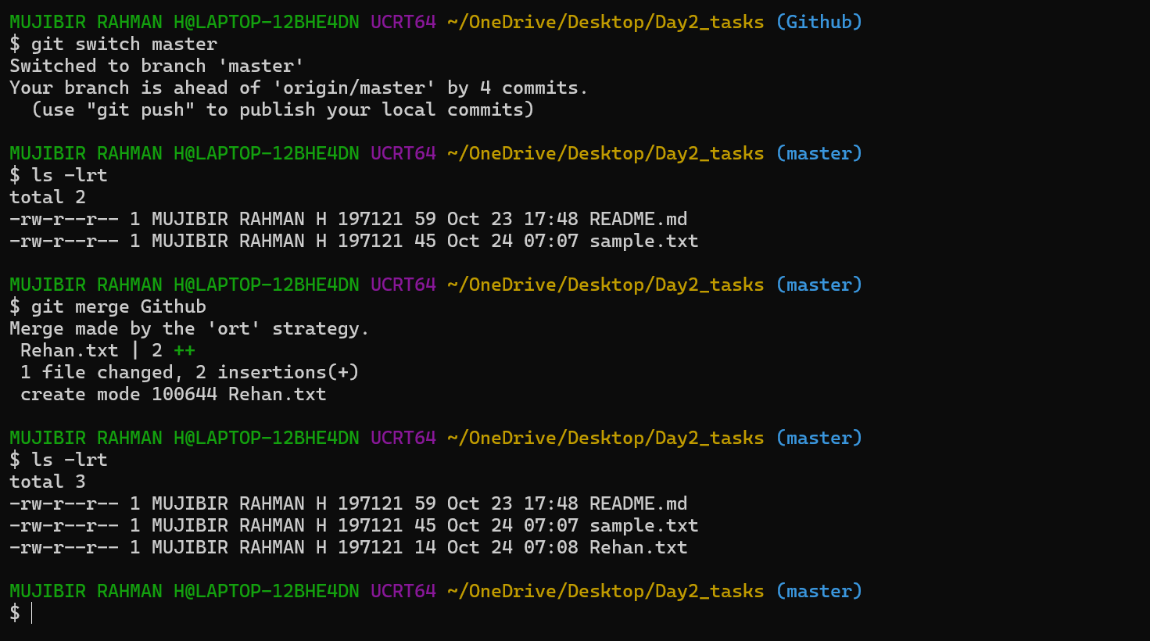
- Merge the created branch with master in github by sending a pull request.
I just created the new pull request and added the Title and description.
Need to determine the base (destination) and compare(source).
After creating the PR, we are able to see Merge pull request- We can merge that easily. (merge commit is automated)
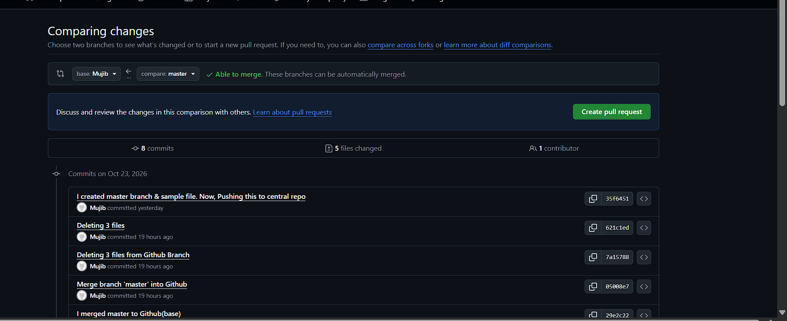
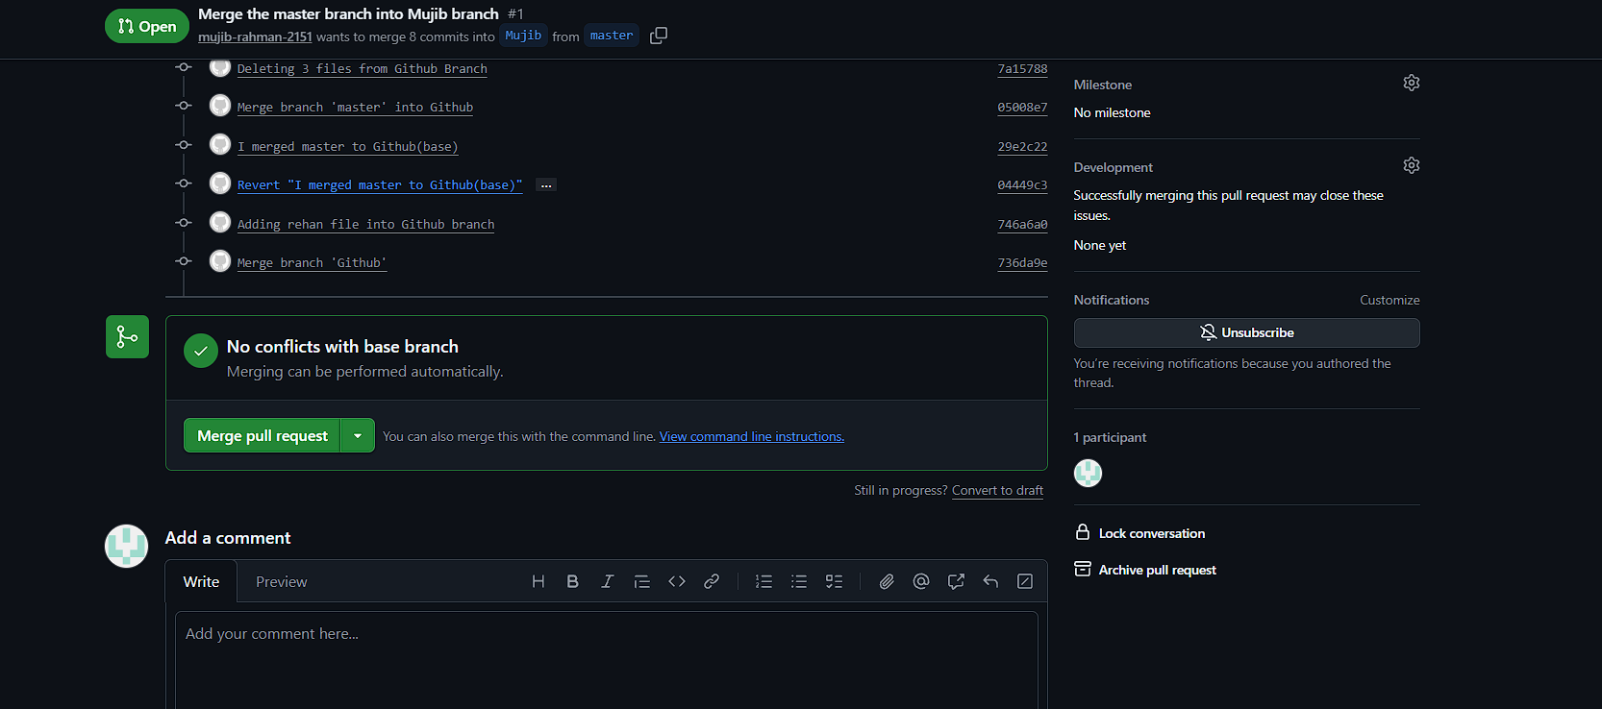
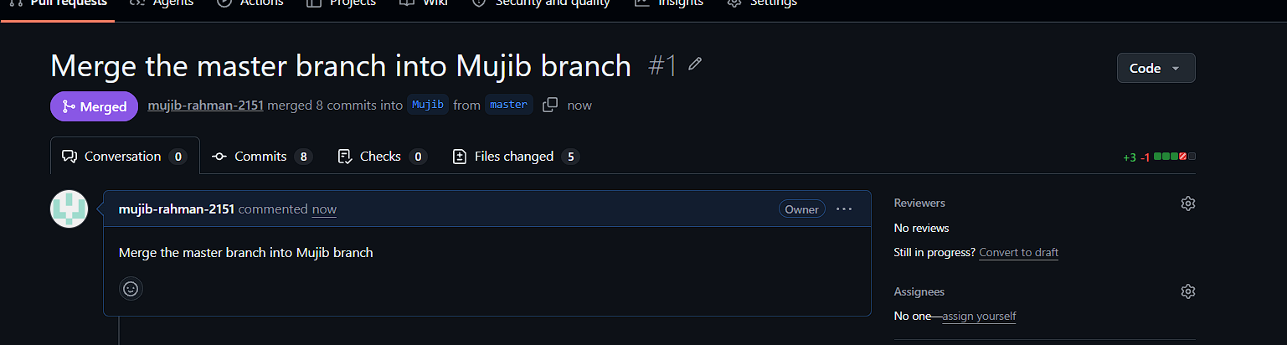
- Create a file in local and send that to branch in github.
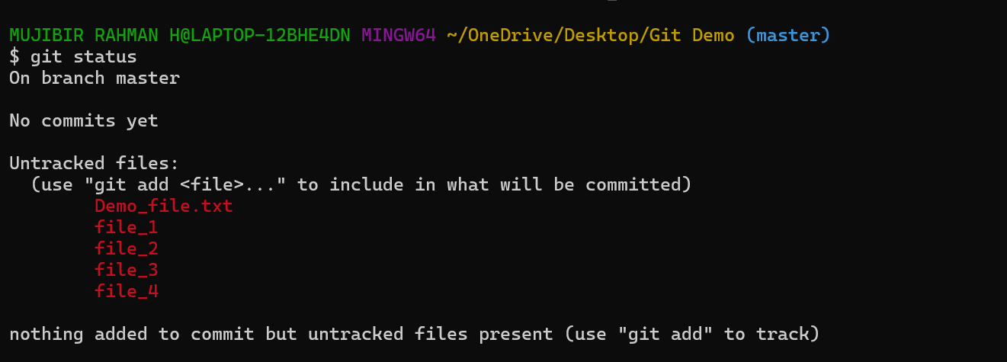
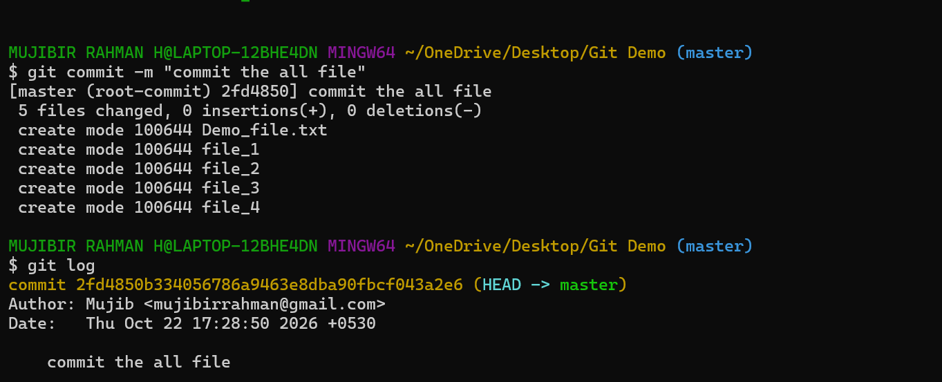
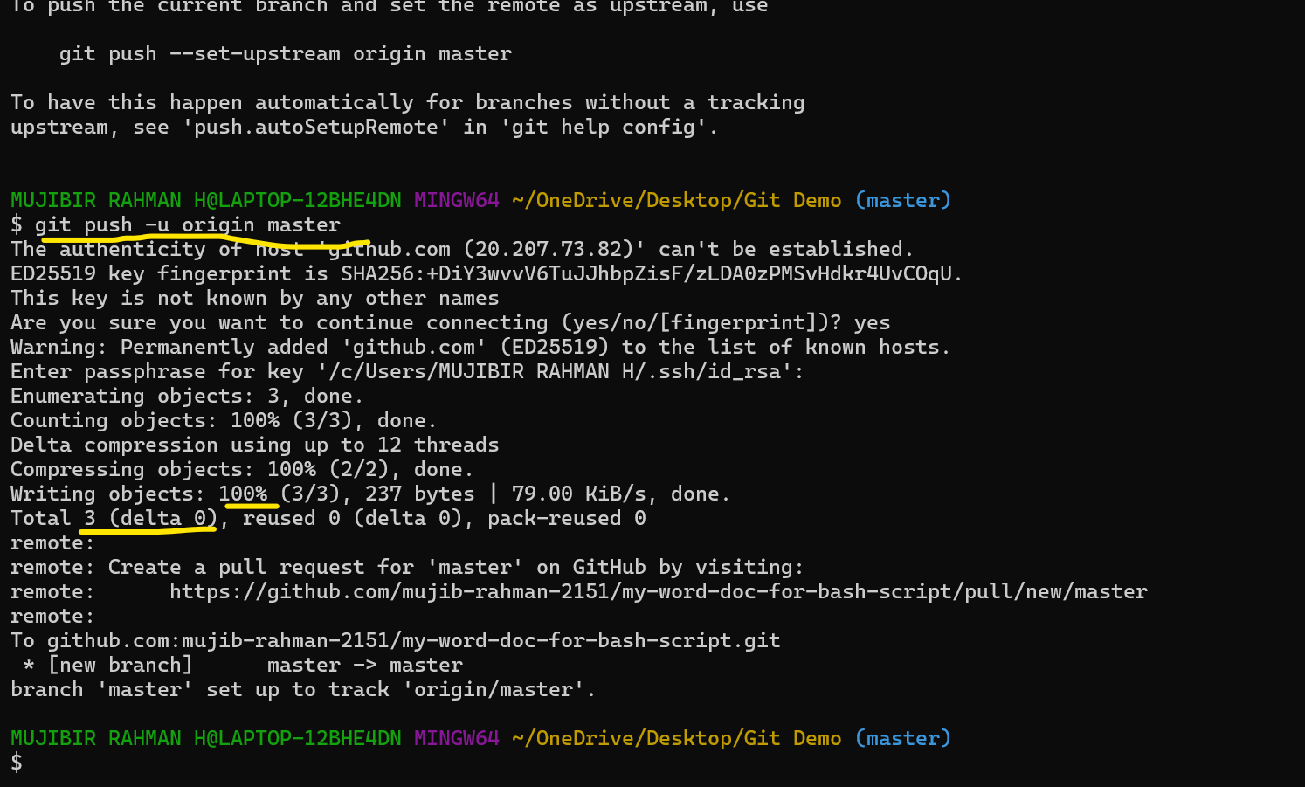
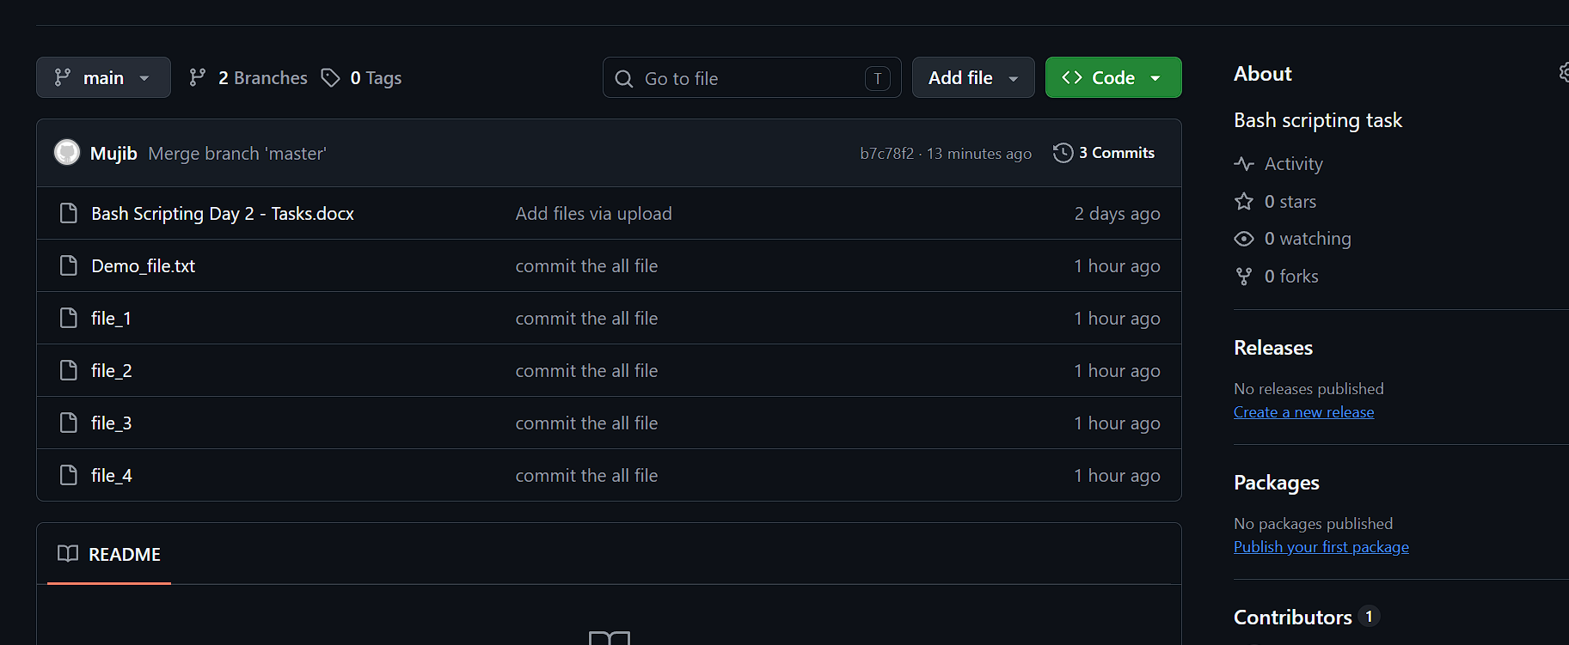
- Clone only a branch from github to local.
I created one branch in Github and tried to clone it on to local.
I faced a error while clone to local (file already exists)
So, I just moved to existing file path
tried to fetch – Using git fetch origin (origin is nothing but that is alias of repository)
git branch I am able to see the branch which I created in github.
- Create a file with all passwords and make that untrackable with git.
I just created a file with my password credentials. I don’t want to access that file in central repo. Because that is my user credentials, that only store in local.
we are using a --.gitignore—Nothing, this will help me to untrack my file in repo…We can add the file in this for our reference. But no one can access or view the content of the file.
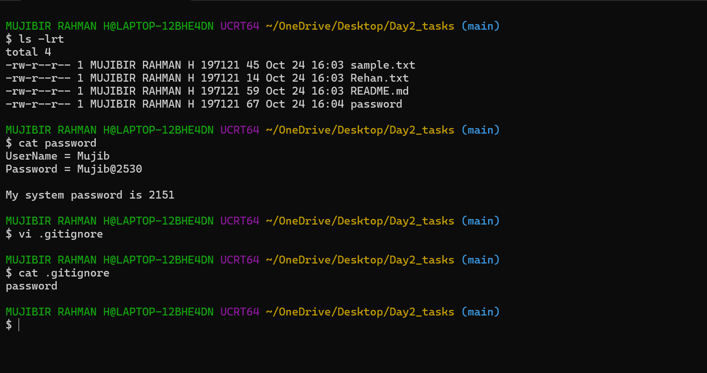
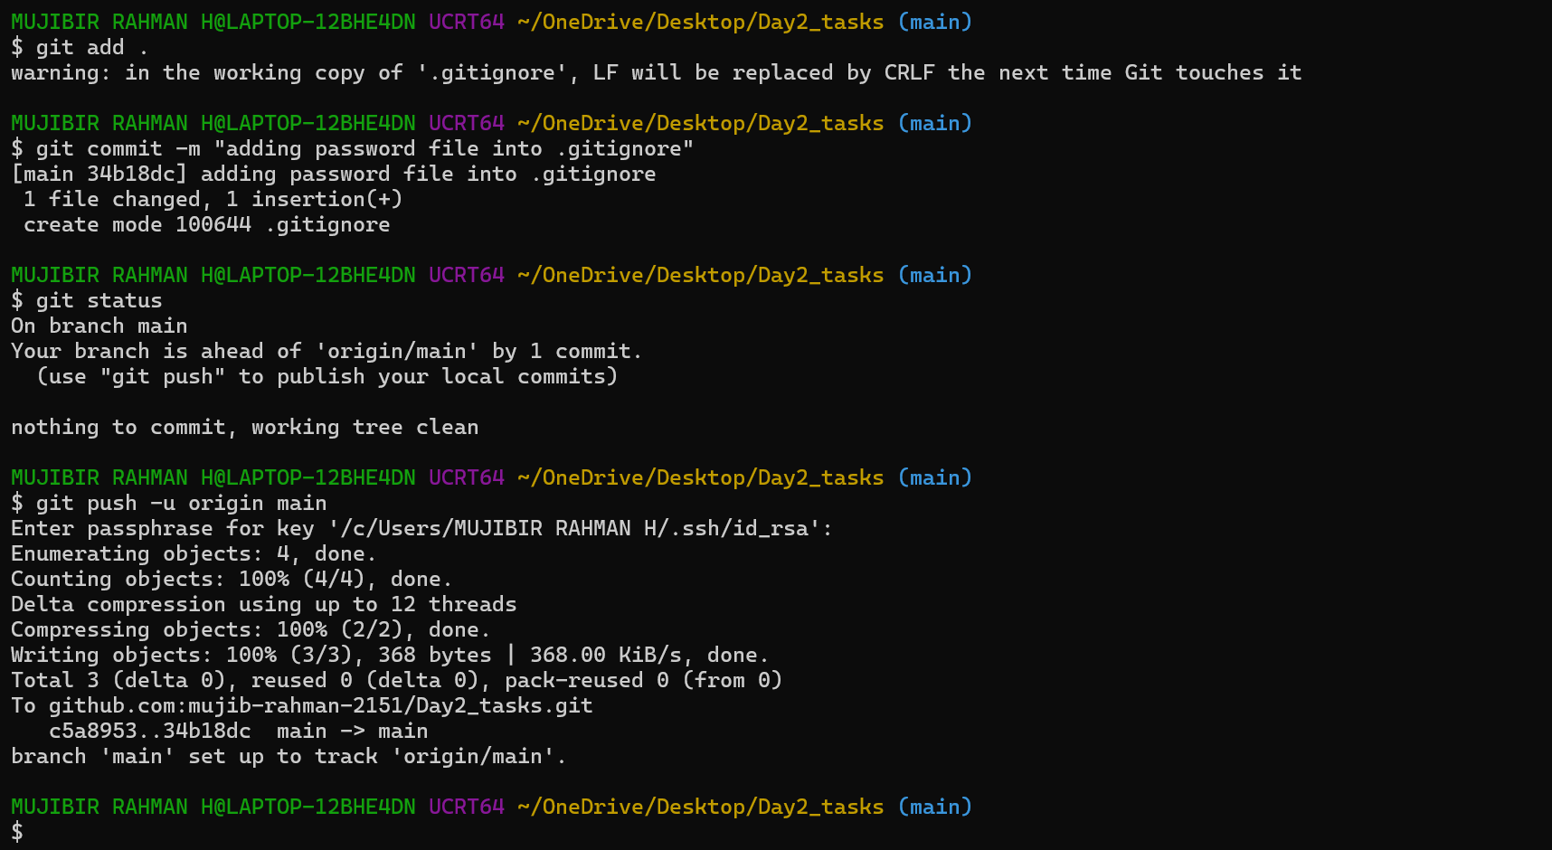
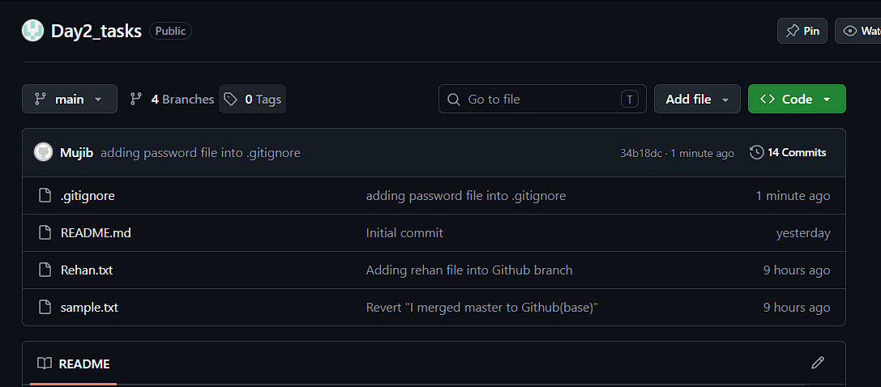
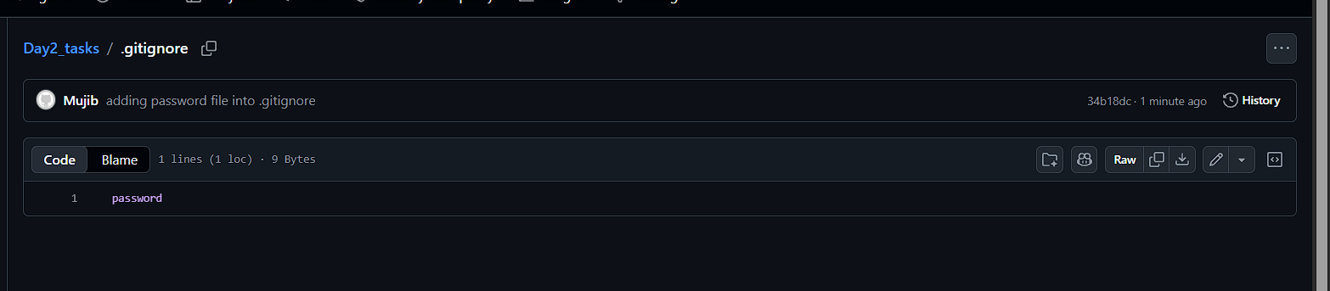
- Make a commit and make that commit reset without savings changes.
git reset Will do reset before push the files or code into repo. Once we pushed, We need to revert it. Reset option will not be safe practice and it will affect other’s work.
hard makes the staging area and working files match that target commit.
Head -1 It’s indicating the latest commit
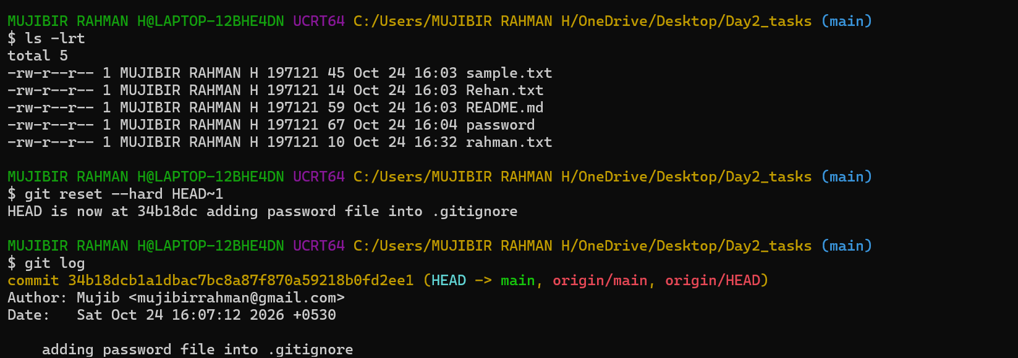
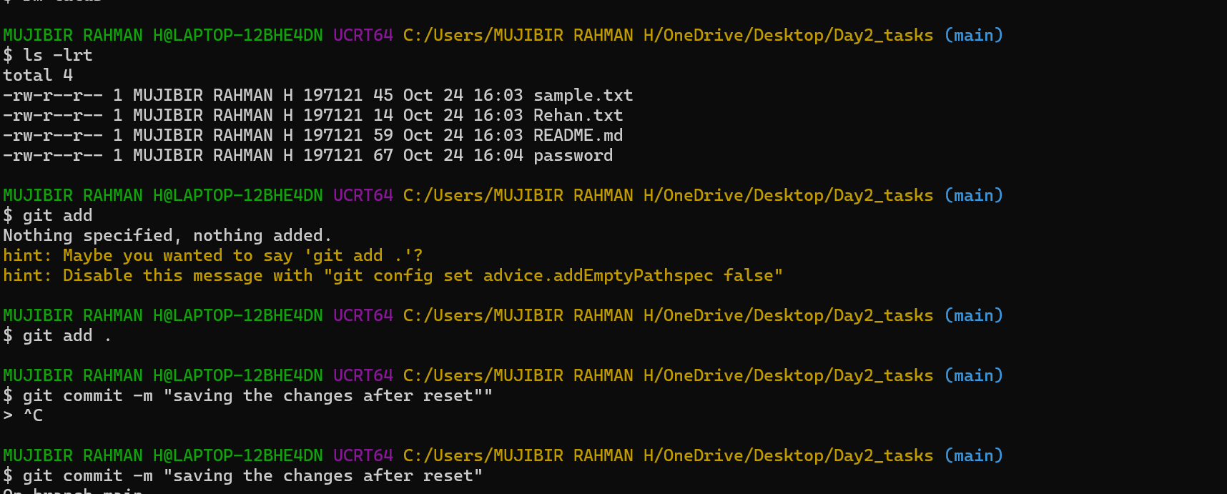
- Revert a commited commit to the older version.
We can revert the changes by using commit ID
This git revert method will generate one new commit again for reverting process. This will help us to track the process.
If someone using the same branch, this changes will not affect them.
git reset option will not be safe practice and it will affect other’s work.
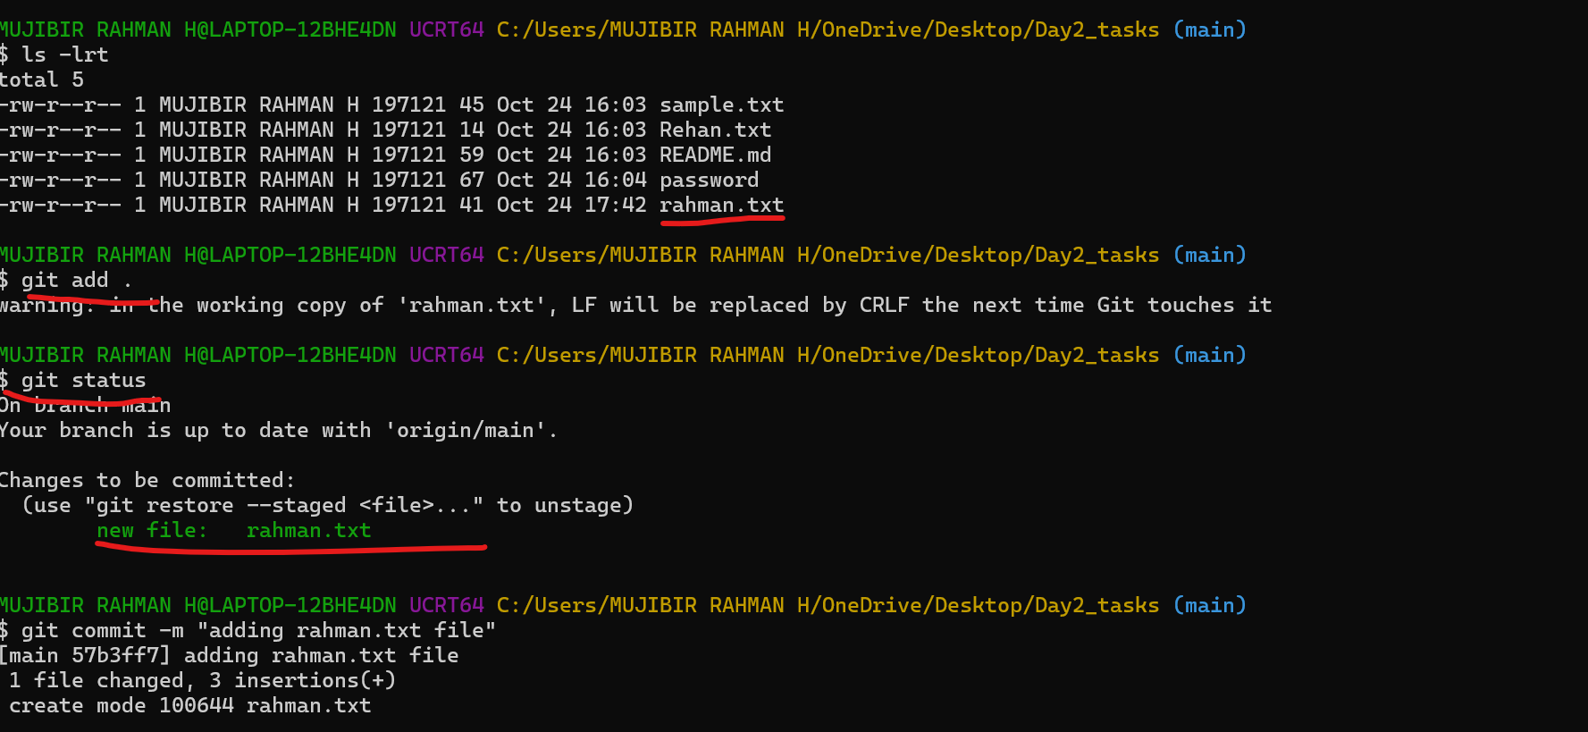
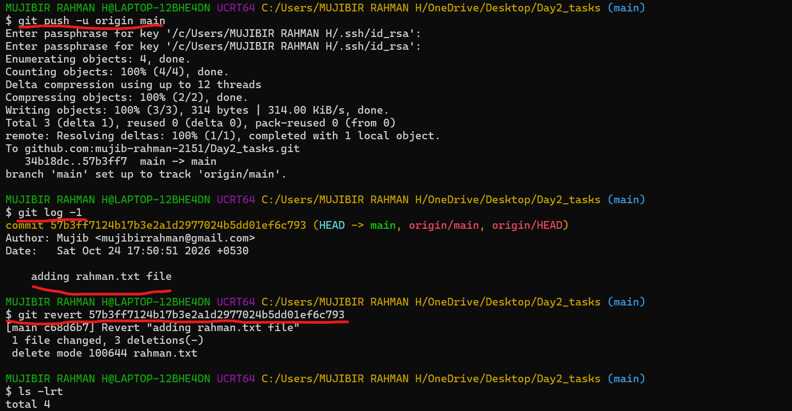
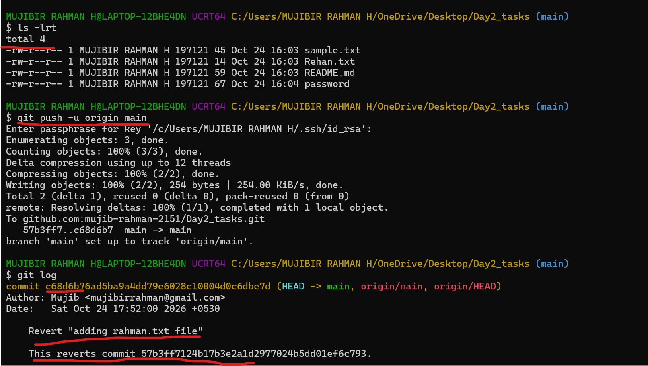
- Push a file to stash without savings the changes and work on another file.
We need to understand clearly, Once the changes committed, Git stash push -m “message” –filename command will not work.
Will list out the stash file using git stash list
Because, stash will help us to store the untracking files/code. If I want to edit/change the files before commit we can work on that later by using git stash pop stash_id command.
This will help to get the untracked file again on our working directory/working branch.
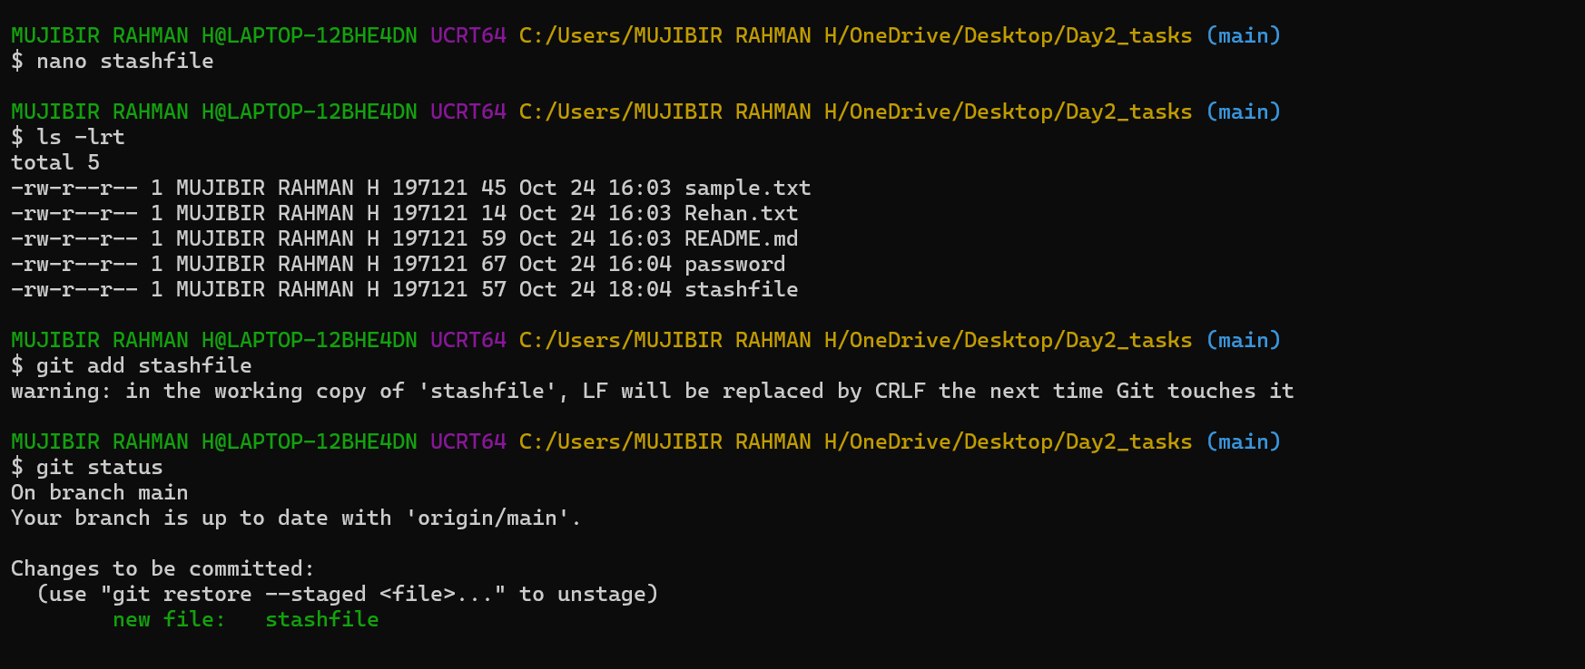
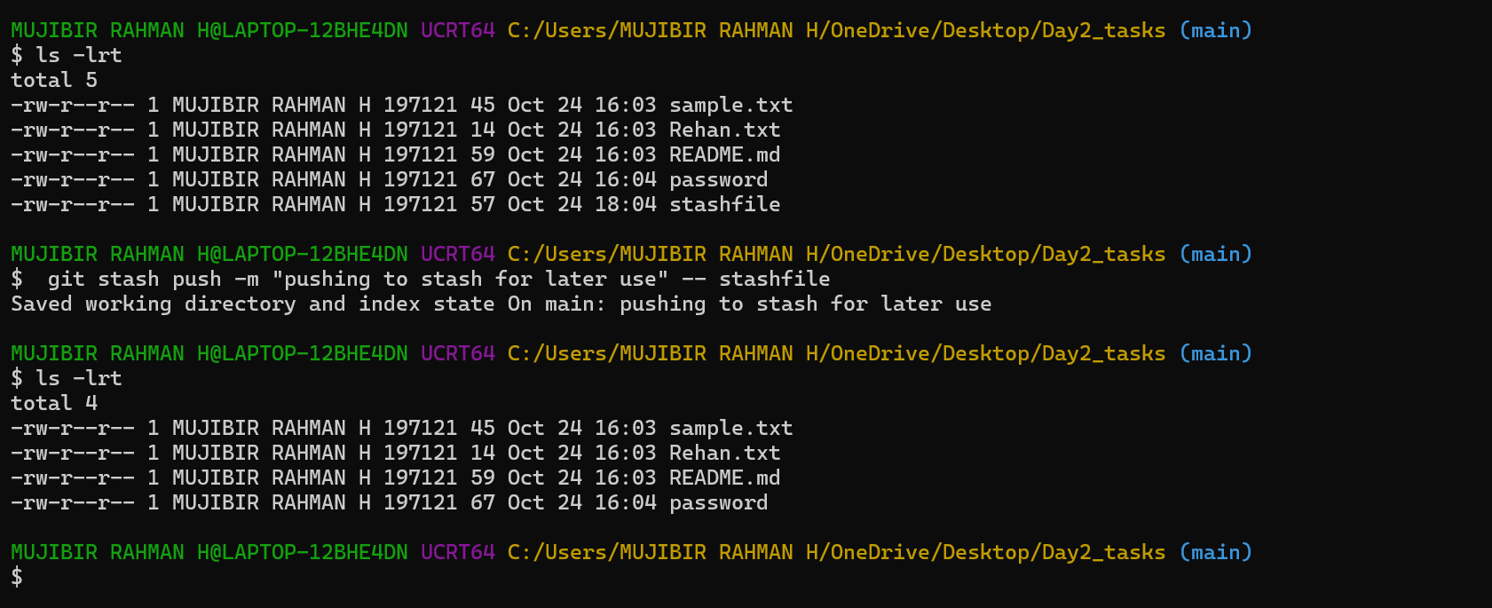
- Undo the stash file and start working on that again.
If I want to edit/change the files before commit we can work on that later by using git stash pop stash_id command.
This will help to get the untracked file again on our working directory/working branch.
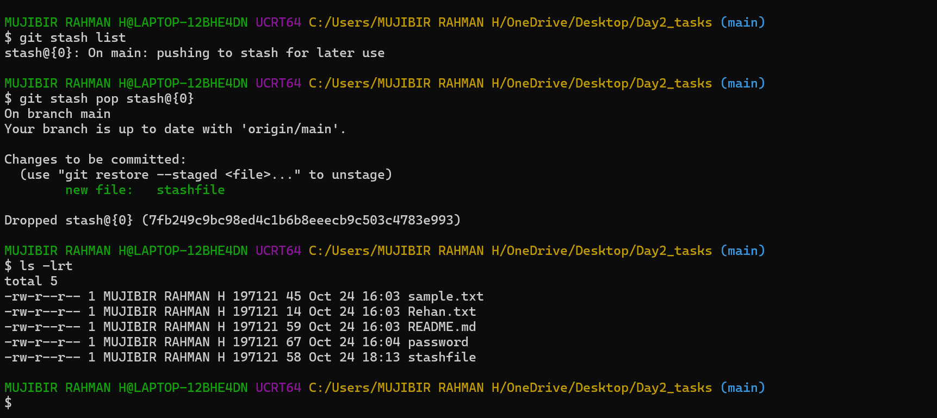
- Generate a ssh-keygen and configure into github.
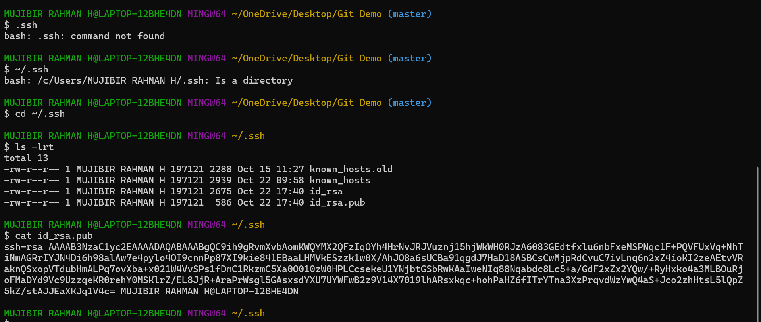
while pushing the source code to github, Will facing some error like permission denied. We need to add our ssh keygen to Github
We need to set the destination path – i.e., We need to create a repo and get the ssh link & add that into
git remote add origin ssh_Link
Now, We execute git remote -v Will able to see destination path.
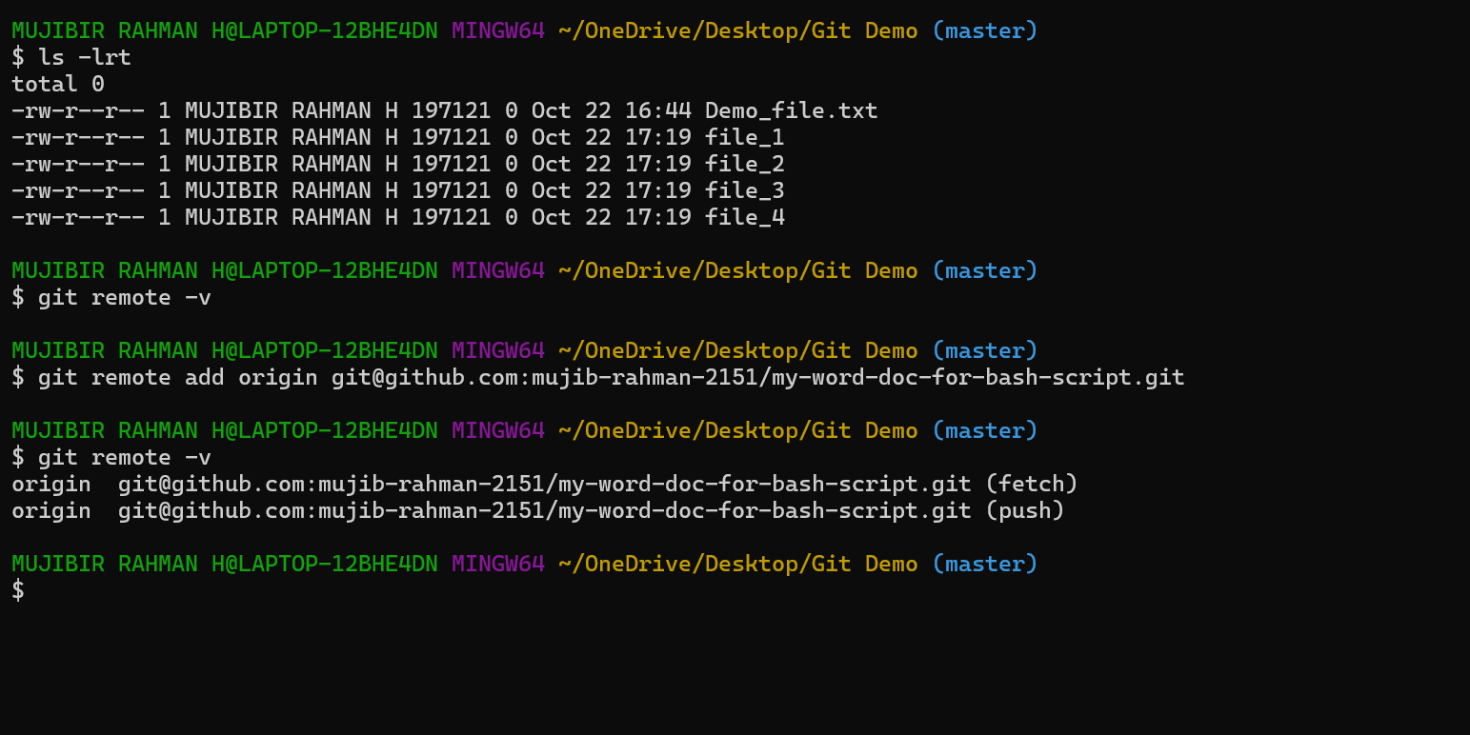
Now, we will able to push the code to github. Pre requisite are ssh-keygen pair needs to be added, destination path we need to determine before push the source code to github.
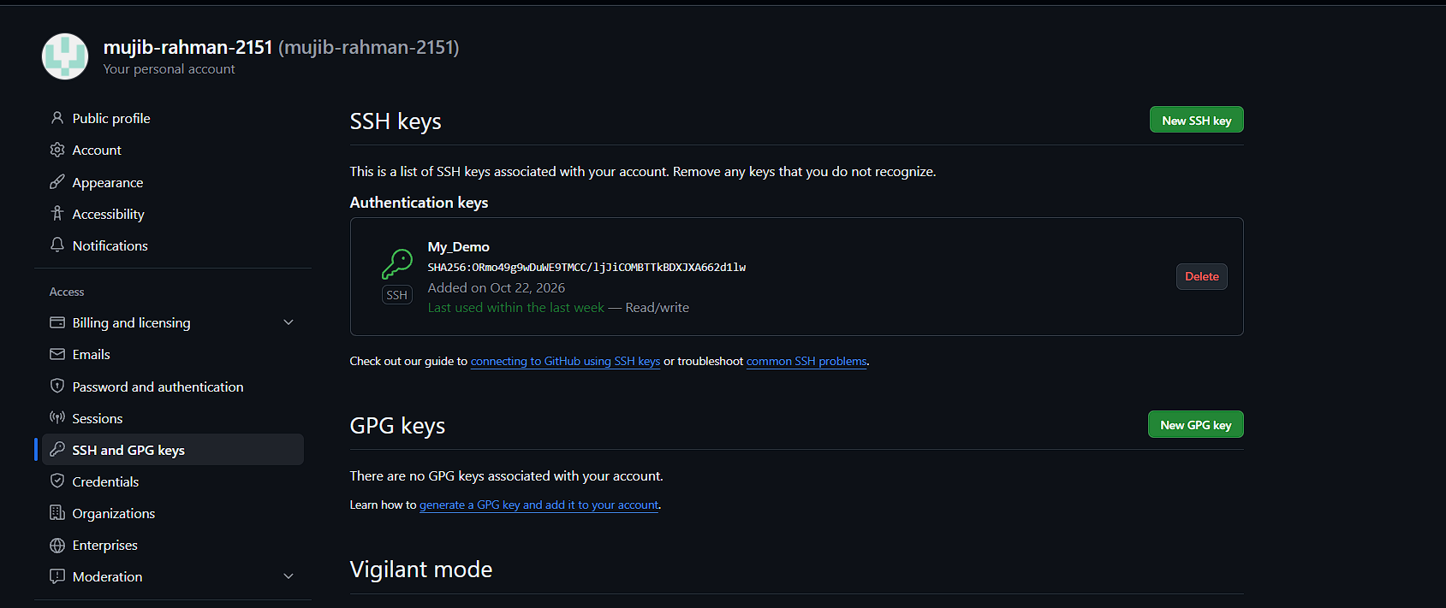
- Configure webhooks to github.
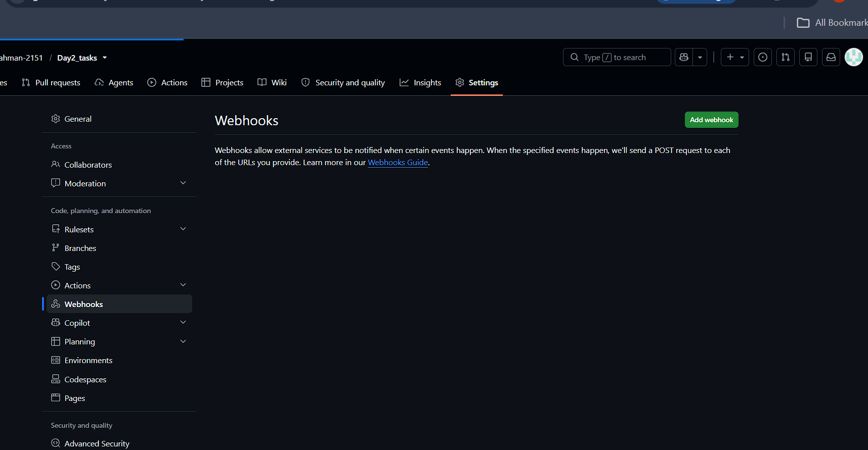
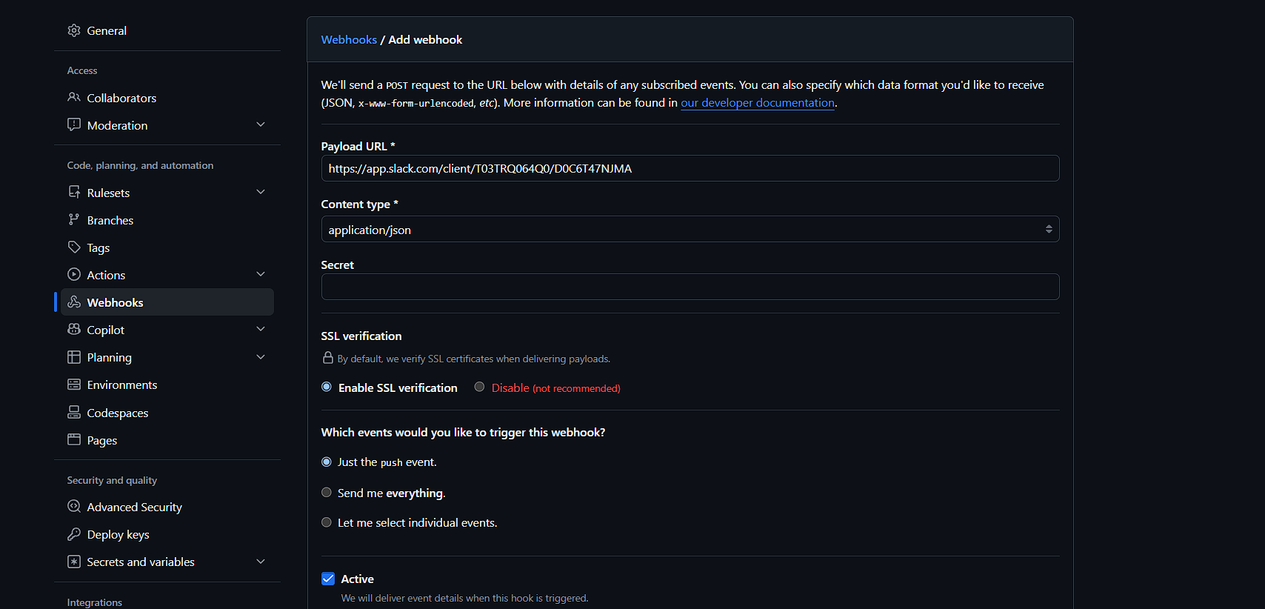
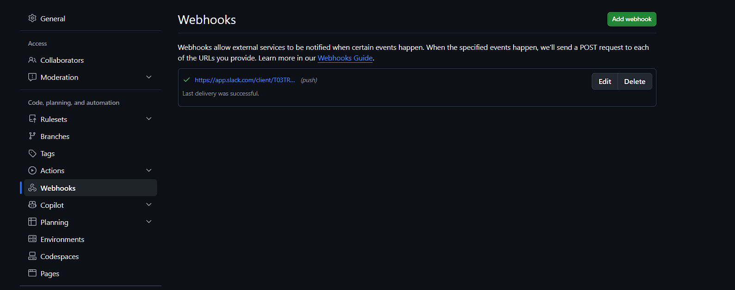
- Basic understanding of .git file.
The .git directory is a hidden folder that stores all the important information Git needs to manage your project.
Example., references, objects, configuration details
- Check all the logs of git.
Git log will help us to track the changes. Any changes/commit we already made, logs will store and we can easily understand.
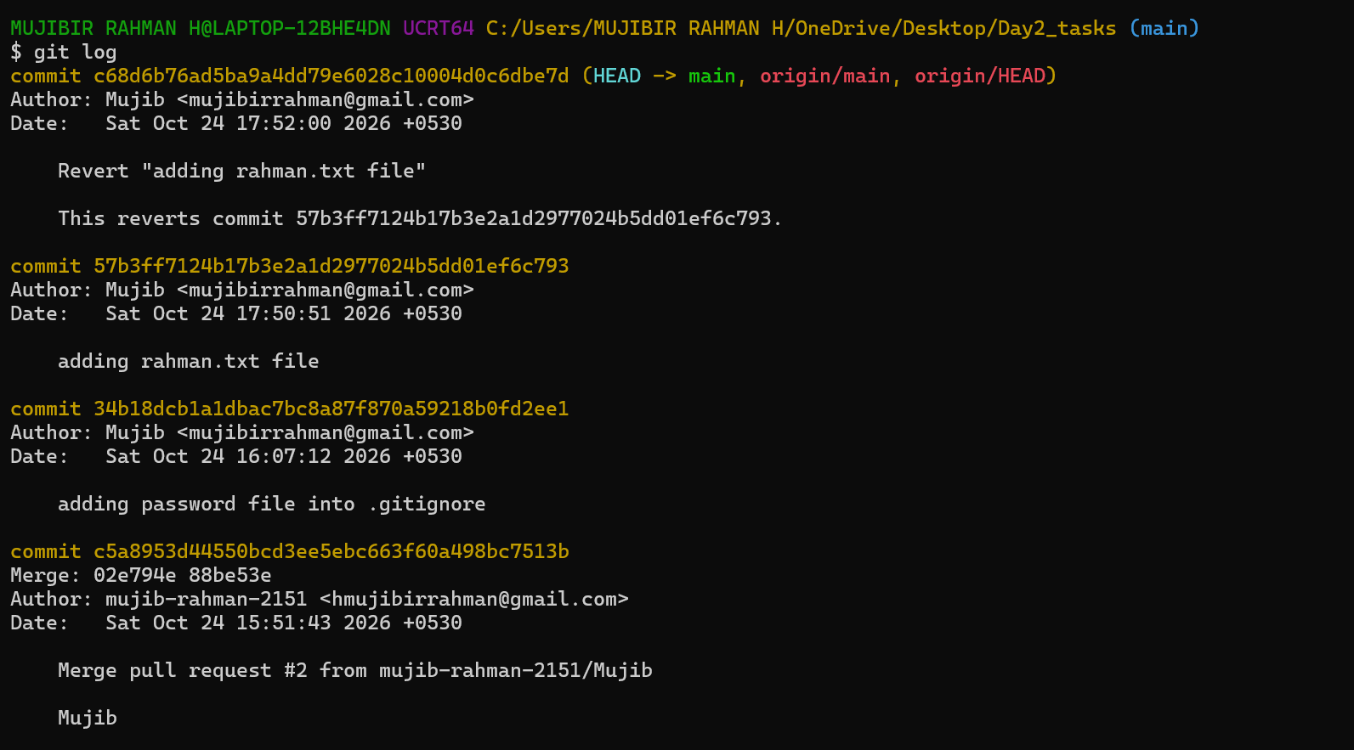
- Rename the commit message.
We are able to rename the commit messages, but that is not a good practice. If that is required we can use git commit -amend -m “updated message”.
It will make the changes on head commit (Latest commit)
If needed change any particular commit message we can use git rebase command.
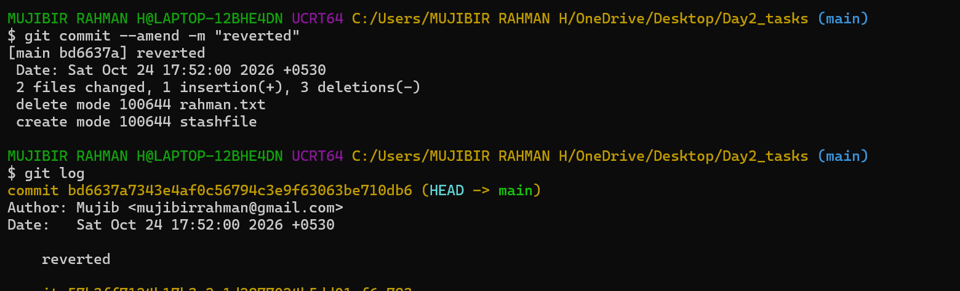
- Merge multiple commits into single commit.
For merging the multiple commit s into single commit using the same command “git rebase -I head~2”
head~2 It’s referring latest two commit ID’s.
I just used the word -- squash -- This word will help/perform for the merging.
(squash meaning - combine)
